TYPING SPEED TEST USING PYTHON

ABSTRACT

The Typing Speed Test is a Python-based application developed to measure the typing speed and accuracy of a user. The program displays a sentence that the user must type. The time taken to type the sentence is recorded, and the typing speed is calculated in Words Per Minute (WPM). The accuracy of the typed text is also measured. This project helps users improve their typing skills while demonstrating the use of Python programming concepts such as GUI development, event handling, time measurement, and string processing.
INTRODUCTION
Typing is an essential skill in today's digital world. Fast and accurate typing improves productivity and efficiency in academic and professional activities. The Typing Speed Test application provides a simple way for users to evaluate their typing performance.

The project is developed using Python and the Tkinter library. The application displays a sentence, records the typing time, and calculates both speed and accuracy. It serves as a practical example of Python GUI programming.
OBJECTIVES
1. To measure the typing speed of a user.
2. To calculate typing accuracy.
3. To improve typing skills through practice.
4. To demonstrate the use of Python GUI programming.
5. To apply event handling and time measurement concepts.
---

SOFTWARE REQUIREMENTS
Hardware Requirements
Computer or Laptop
Minimum 4 GB RAM
Keyboard
Software Requirements
Python 3.x
Thonny IDE
Operating System (Windows/Linux)

---

METHODOLOGY

The project works as follows:

1. A random sentence is displayed on the screen.
2. The user clicks the Start button.
3. The timer begins.
4. The user types the displayed sentence.
5. After completing the sentence, the user presses Enter.
6. The program calculates the time taken.
7. The typing speed in Words Per Minute (WPM) is calculated.
8. The typing accuracy is calculated.
9. The results are displayed on the screen.
---

ALGORITHM

1. Start the program.
2. Display a random sentence.
3.Wait for the user to click the Start button.
4. Record the start time.
5. Accept user input.
6. Record the end time when Enter is pressed.
7. Calculate Words Per Minute (WPM).
8. Calculate typing accuracy.
9. Display the results.
10. End the program.
---

FEATURES
Simple graphical user interface.
Random sentence generation.
Typing speed calculation.
Accuracy measurement.
Easy to use and understand.
Suitable for beginners.
---

RESULTS
The Typing Speed Test application successfully measures:
Typing Speed (Words Per Minute)
Typing Accuracy Percentage

The results are displayed immediately after the user completes the typing test.

Output Screenshot 1: Main application window displaying the sentence.

Output Screenshot 2: Result screen displaying WPM and Accuracy.
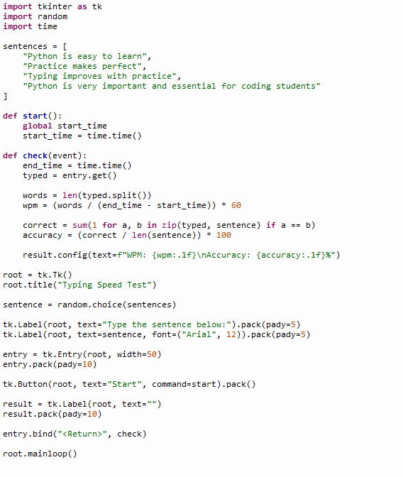

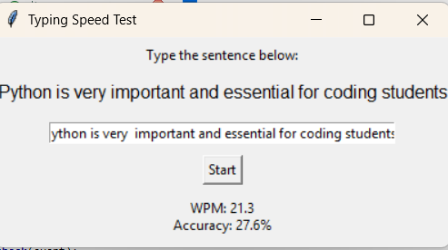
---

ADVANTAGES
Helps improve typing skills.
Easy to use.
Provides instant feedback.
Demonstrates Python GUI programming concepts.
Useful for students and beginners.
---

FUTURE ENHANCEMENTS

Add multiple difficulty levels.
Store user scores in a database.
Display typing history.
Add a leaderboard system.
Include more sentences and paragraphs.

CONCLUSION
The Typing Speed Test project successfully demonstrates the use of Python programming for developing a graphical user interface application. The project measures typing speed and accuracy effectively. It is simple, user-friendly, and useful for improving typing skills. The project also helps students understand important Python concepts such as event handling, GUI development, and time measurement.

---

REFERENCES
1. Python Official Documentation
2. Tkinter Documentation
3. Python Programming Textbook.
4. Online Python Tutorials

